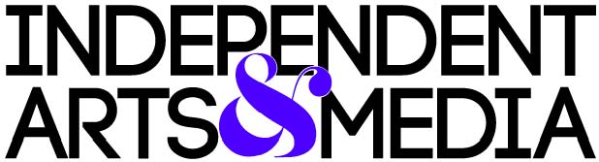

Fiscal Sponsorship Application

Independent Arts & Media offers fiscal sponsorship to art and media projects for the purpose of advancing IAM’s charitable purpose: “[to] raise and support the educational, cultural, and social levels of, and expand the related opportunities available to, the residents of the San Francisco Bay Area and surrounding regional and national communities, including members of under-served, minority, and low-income communities, through the development of non-commercial projects for the benefit of the general public, including, but not limited to, educational, cultural, community, media, news, and art-related projects.”

Your complete application must include the following:

- IAM Fiscal Sponsorship Application Form

- Projected Budget Spreadsheet & Budget Notes. The IAM Board of Directors will carefully review your projected operating budget and funding strategies to assess the feasibility and scope of your Project.

- Brief list of project leaders and key participating artists, producers, writers, etc., including names, titles, professional background, and a short description of their project responsibilities.

- OPTIONAL supporting materials and work samples, such as business and strategic plans, brochures, event programs, marketing materials, press releases, media clippings.

Please direct all questions, as well as your completed application, to admin@artsandmedia.net.

Project Name:
Project Website:

Applicant Name:
Contact (if different from Applicant):
Phone:
Email:
Mailing Address:

Which type of fiscal sponsorship are you applying for? (see IAM website for details)

- Model A “Comprehensive Sponsorship” (12% admin fee)
- Model C “Pre-Approved Regranting” (10% admin fee)
- Model C+ (“Pre-Approved Regranting” with additional bill pay services) (11% admin fee)
- Are you currently fiscally sponsored? If yes with whom and why are you seeking a new sponsor?

- What is the Project's overall mission and how does it align with IAM’s mission ("to steward and empower independent art and media projects that foster community and civic participation, and facilitate cultural engagement and free expression”)? (250 words max)

- Please describe your project, including history, purpose, anticipated outcomes, and goals. (500 words max)

- What is your funding strategy for your first year of operations? What funds are already committed to the Project? Do you have a “Plan B” for identifying funding for your project? (500 words max)

- What is the long-term goal of your project? Are you currently applying for or do you anticipate applying for 501(c)(3) status? (100 words max)

- In what areas do you see yourself needing support?
- Program Development
- Strategic or Organizational Planning
- Accounting and financial management
- Fundraising strategy
- Grant research and writing
- Budgeting
- Marketing / social media management

WHAT HAPPENS NEXT?

You will receive an email confirming receipt within 2-3 business days. You will then be invited to speak with the IAM Executive Director about your Project and application.

Thank you for considering Independent Arts & Media as your fiscal sponsor.

We exist to steward and empower independent art and media projects that foster community and civic participation, and facilitate cultural engagement and free expression. We are honored by your interest and hope that we can be of service to your public-interest work.

